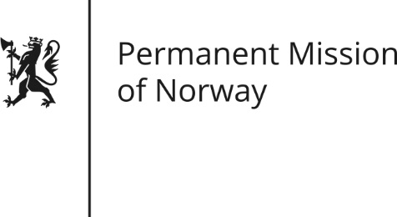

STATEMENT
Universal Periodic Review (UPR): TIMOR-LESTE

by Human Rights Advisor Marius Mikkel Kjølstad
Thursday 3 November 2016

Check against delivery

Norway welcomes the delegation from Timor-Leste and acknowledges Timor-Leste’s efforts to improve the human rights situation in the country since their last UPR.
Gender equality is one of the most effective drivers of economic development, fair distribution, peace, and democracy. In this regard Norway recognises Timor-Leste’s efforts in securing increased political participation for women, not only in parliament where more than a third of the parliamentarians are women, but also in adopting an election law that ensures representation of women also on local and regional ballots. Still, women unfortunately continue to suffer disproportionally from domestic abuse. Norway recommends that Timor-Leste ensure implementation of the second phase of the National Action Plan on Gender Based Violence and continue efforts to improve access to justice and shelter for victims of abuse. We further recommend that Timor Leste consider reviewing the provisions in its penal code which contain punitive measures against women who have undergone illegal abortions.
Free media is of great importance to ensure open and constructive dialogue. Norway recommends implementation of the Media Law in line with all obligations under international human rights law.
Norway gives high priority to promoting access to education as this, in addition to being a basic human right, is an absolute requirement for economic growth anywhere. We recommend that Timor-Leste continue efforts to increase the quality of and accessibility to education, including adequate resourcing of teacher training and oversight.
Timor-Leste is a young nation which has made tremendous achievements in a multitude of areas since its independence. Considering the country’s history and the testimonies in the CHEGA!-report on past human rights abuses, Norway recommends that Timor-Leste prioritise and resolve past crimes, through accelerating the discussion and approval of draft laws on reparations and the memory institute.

